3.1.1 Random Variables
In general, to analyze random experiments, we usually focus on some numerical aspects of the experiment. For example, in a soccer game we may be interested in the number of goals, shots, shots on goal, corners kicks, fouls, etc. If we consider an entire soccer match as a random experiment, then each of these numerical results gives some information about the outcome of the random experiment. These are examples of random variables. In a nutshell, a random variable is a real-valued variable whose value is determined by an underlying random experiment.
Let's look at an example.
Example
I toss a coin five times. This is a random experiment and the sample space can be written as
S={TTTTT,TTTTH,...,HHHHH}.
Note that here the sample space S has 2^5=32 elements. Suppose that in this experiment, we are interested in the number of heads. We can define a random variable X whose value is the number of observed heads. The value of X will be one of 0,1,2,3,4 or 5 depending on the outcome of the random experiment.

In essence, a random variable is a real-valued function that assigns a numerical value to each possible outcome of the random experiment. For example, the random variable X defined above assigns the value 0 to the outcome TTTTT, the value 2 to the outcome THTHT, and so on. Hence, the random variable X is a function from the sample space S={TTTTT,TTTTH, ⋯⋯ ,HHHHH} to the real numbers (for this particular random variable, the values are always integers between 0 and 5).

Random Variables:
A random variable X is a function from the sample space to the real numbers.
X:S→R

We usually show random variables by capital letters such as X, Y, and Z. Since a random variable is a function, we can talk about its range. The range of a random variable X, shown by Range(X) or RX, is the set of possible values for X. In the above example, Range(X)=RX={0,1,2,3,4,5}

The range of a random variable X, shown by Range(X) or RX, is the set of possible values of X.

Example
Find the range for each of the following random variables.
- I toss a coin 100100 times. Let X be the number of heads I observe.
- I toss a coin until the first heads appears. Let Y be the total number of coin tosses.
- The random variable T is defined as the time (in hours) from now until the next earthquake occurs in a certain city.
    - The random variable X can take any integer from 00 to 100100,so RX={0,1,2,...,100}
    - The random variable Y can take any positive integer, so RY={1,2,3,...}=N.
    - The random variable T can in theory get any nonnegative real number, so RT=[0,∞)

3.1.2 Discrete Random Variables
There are two important classes of random variables that we discuss in this book: discrete random variables and continuous random variables. We will discuss discrete random variables in this chapter and continuous random variables in Chapter 4. There will be a third class of random variables that are called mixed random variables. Mixed random variables, as the name suggests, can be thought of as mixture of discrete and continuous random variables. We will discuss mixed random variables in Chapter 4 as well.
Remember that a set A is countable if either
- A is a finite set such as {1,2,3,4}, or
- it can be put in one-to-one correspondence with natural numbers (in this case the set is said to be countably infinite)
In particular, as we discussed in Chapter 1, sets such as N,Z,Q and their subsets are countable, while sets such as nonempty intervals [a,b] in R are uncountable. A random variable is discrete if its range is a countable set. In Example 3.2, the random variables X and Y are discrete, while the random variable T is not discrete.

X is a discrete random variable, if its range is countable.

3.1.3 Probability Mass Function (PMF)
If X is a discrete random variable then its range RX is a countable set, so, we can list the elements in RX. In other words, we can write
RX={x1,x2,x3,...}.
Note that here x1,x2,x3,... are possible values of the random variable X. While random variables are usually denoted by capital letters, to represent the numbers in the range we usually use lowercase letters such as x, x1, y, z, etc. For a discrete random variable X, we are interested in knowing the probabilities of X=xk. Note that here, the event A={X=xk}is defined as the set of outcomes s in the sample space S for which the corresponding value of X is equal to xk. In particular,
A={s∈S|X(s)=xk}.
The probabilities of events {X=xk} are formally shown by the probability mass function (pmf) of X.

Definition
Let X be a discrete random variable with range RX={x1,x2,x3,...} (finite or countably infinite). The function
PX(xk)=P(X=xk), , for k=1,2,3,...,
is called the probability mass function (PMF) of X.

Thus, the PMF is a probability measure that gives us probabilities of the possible values for a random variable. While the above notation is the standard notation for the PMF of X, it might look confusing at first. The subscript X here indicates that this is the PMF of the random variable X. Thus, for example, PX(1) shows the probability that X=1. To better understand all of the above concepts, let's look at some examples.

Example
I toss a fair coin twice, and let X be defined as the number of heads I observe. Find the range of X, RX, as well as its probability mass function PX.

- Here, our sample space is given by
S={HH,HT,TH,TT}.
The number of heads will be 00, 1 or 2. Thus
RX={0,1,2}.
Since this is a finite (and thus a countable) set, the random variable X is a discrete random variable. Next, we need to find PMF of X. The PMF is defined as
PX(k)=P(X=k) for k=0,1,2.
We have
PX(0)=P(X=0)=P(TT)=14,
PX(1)=P(X=1)=P({HT,TH})=14+14=12,
PX(2)=P(X=2)=P(HH)=14.
Although the PMF is usually defined for values in the range, it is sometimes convenient to extend the PMF of X to all real numbers. If x∉RX, we can simply write PX(x)=P(X=x)=0. Thus, in general we can write

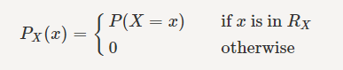
To better visualize the PMF, we can plot it. Figure 3.1 shows the PMF of the above random variable X. As we see, the random variable can take three possible values 0,1 and 2. The figure also clearly indicates that the event X=1 is twice as likely as the other two possible values. The Figure can be interpreted in the following way: If we repeat the random experiment (tossing a coin twice) a large number of times, then about half of the times we observe X=1, about a quarter of times we observe X=0, and about a quarter of times we observe X=2.

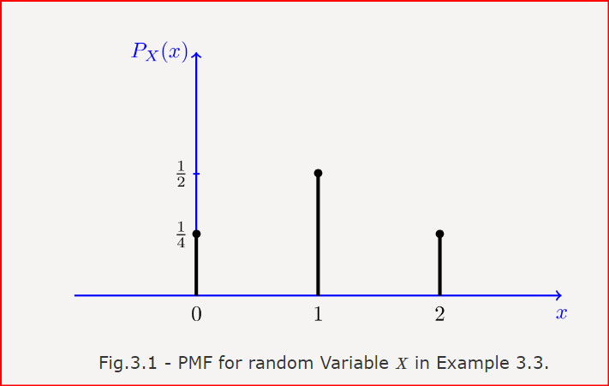

For discrete random variables, the PMF is also called the probability distribution. Thus, when asked to find the probability distribution of a discrete random variable X, we can do this by finding its PMF. The phrase distribution function is usually reserved exclusively for the cumulative distribution function CDF (as defined later in the book). The word distribution, on the other hand, in this book is used in a broader sense and could refer to PMF, probability density function (PDF), or CDF.

Example
I have an unfair coin for which P(H)=p, where 0<p<1. I toss the coin repeatedly until I observe a heads for the first time. Let Y be the total number of coin tosses. Find the distribution of Y.

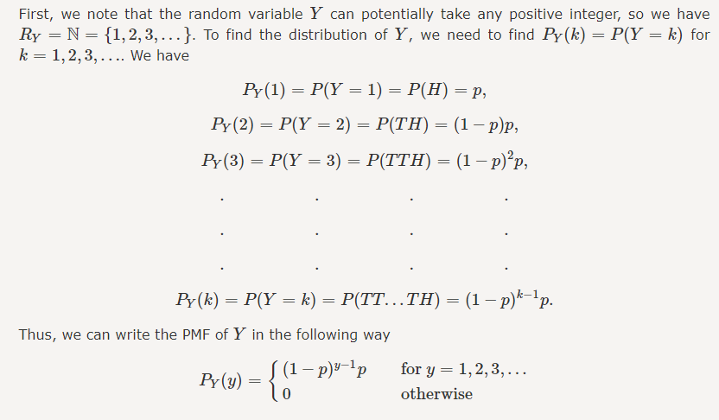
Consider a discrete random variable X with Range(X)=RX. Note that by definition the PMF is a probability measure, so it satisfies all properties of a probability measure. In particular, we have
- 0≤PX(x)≤1for all x, and
- ∑x∈RX PX(x)=1
Also note that for any set A⊂RX, we can find the probability that X∈A using the PMF
P(X∈A)=∑x∈A PX(x).

Properties of PMF:
- 0≤PX(x)≤1 for all x;
- ∑x∈RX PX(x)=1;
- for any set A⊂RX,P(X∈A)=∑x∈A PX(x).
Example
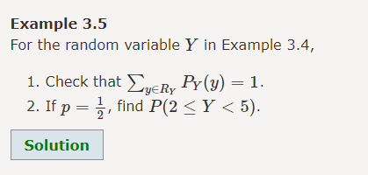

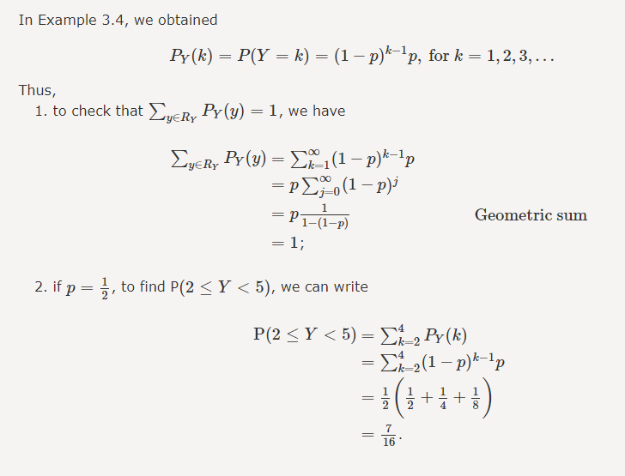

3.1.4 Independent Random Variables
In real life, we usually need to deal with more than one random variable. For example, if you study physical characteristics of people in a certain area, you might pick a person at random and then look at his/her weight, height, etc. The weight of the randomly chosen person is one random variable, while his/her height is another one. Not only do we need to study each random variable separately, but also we need to consider if there is dependence (i.e., correlation) between them. Is it true that a taller person is more likely to be heavier or not? The issues of dependence between several random variables will be studied in detail later on, but here we would like to talk about a special scenario where two random variables are independent.
The concept of independent random variables is very similar to independent events. Remember, two events A and B are independent if we have P(A,B)=P(A)P(B) (remember comma means and, i.e., P(A,B)=P(A and B)=P(A∩B) Similarly, we have the following definition for independent discrete random variables.

-----------------------------------------------------------------------------------

Definition
Consider two discrete random variables X and Y. We say that X and Y are independent if
P(X=x,Y=y)=P(X=x)P(Y=y), for all x,y.
In general, if two random variables are independent, then you can write
P(X∈A,Y∈B)=P(X∈A)P(Y∈B), for all sets A and B.
-----------------------------------------------------------------------------------

Intuitively, two random variables X and Y are independent if knowing the value of one of them does not change the probabilities for the other one. In other words, if X and Y are independent, we can write
P(Y=y|X=x)=P(Y=y), for all x,y.
Similar to independent events, it is sometimes easy to argue that two random variables are independent simply because they do not have any physical interactions with each other. Here is a simple example: I toss a coin 2N times. Let X be the number of heads that I observe in the first N coin tosses and let Y be the number of heads that I observe in the second N coin tosses. Since X and Y are the result of independent coin tosses, the two random variables X and Y are independent. On the other hand, in other scenarios, it might be more complicated to show whether two random variables are independent.

Example
I toss a coin twice and define X to be the number of heads I observe. Then, I toss the coin two more times and define Y to be the number of heads that I observe this time. Find P((X<2) and (Y>1))
- Solution
- Since X and Y are the result of different independent coin tosses, the two random variables X and Y are independent. Also, note that both random variables have the distribution we found in Example 3.3. We can write
P((X<2) and (Y>1)) | =P(X<2)P(Y>1)(because X and Y are independent)
 | =(PX(0)+PX(1))PY(2)=
 | =(1/4+1/2)1/4=
 | =3/16
We can extend the definition of independence to n random variables

Definition
Consider n discrete random variables X1,X2,X3,...,Xn We say that X1,X2,X3,...,Xn are independent if
P(X1=x1,X2=x2,...,Xn=xn) =P(X1=x1)P(X2=x2)...P(Xn=xn), for all x1,x2,...,xn.

3.1.5 Special Distributions
As it turns out, there are some specific distributions that are used over and over in practice, thus they have been given special names. There is a random experiment behind each of these distributions. Since these random experiments model a lot of real life phenomenon, these special distributions are used frequently in different applications. That's why they have been given a name and we devote a section to study them. We will provide PMFs for all of these special random variables, but rather than trying to memorize the PMF, you should understand the random experiment behind each of them. If you understand the random experiments, you can simply derive the PMFs when you need them. Although it might seem that there are a lot of formulas in this section, there are in fact very few new concepts. Do not get intimidated by the large number of formulas, look at each distribution as a practice problem on discrete random variables.

Bernoulli Distribution
What is the simplest discrete random variable (i.e., simplest PMF) that you can imagine? My answer to this question is a PMF that is nonzero at only one point. For example, if you define
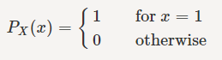
then X is a discrete random variable that can only take one value, i.e., X=1with a probability of one. But this is not a very interesting distribution because it is not actually random. Then, you might ask what is the next simplest discrete distribution. And my answer to that is the Bernoulli distribution. A Bernoulli random variable is a random variable that can only take two possible values, usually 0 and 1. This random variable models random experiments that have two possible outcomes, sometimes referred to as "success" and "failure." Here are some examples:
- You take a pass-fail exam. You either pass (resulting in X=1) or fail (resulting in X=0).
- You toss a coin. The outcome is either heads or tails.
- A child is born. The gender is either male or female.
Formally, the Bernoulli distribution is defined as follows:

Definition
A random variable X is said to be a Bernoulli random variable with parameter p, shown as X∼Bernoulli(p) if its PMF is given by

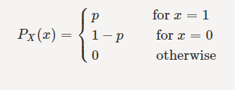
where 0<p<1

Figure 3.2 shows the PMF of a Bernoulli(p) random variable.

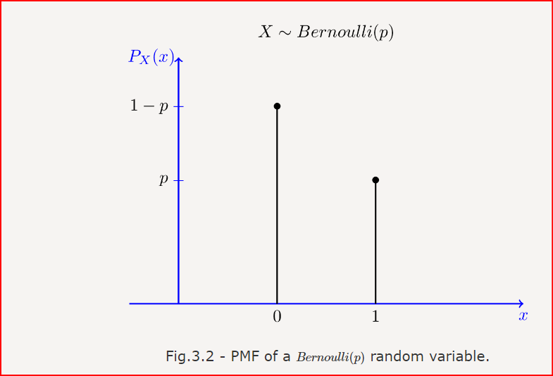

A Bernoulli random variable is associated with a certain event A. If event A occurs (for example, if you pass the test), then X=1; otherwise X=0. For this reason the Bernoulli random variable, is also called the indicator random variable. In particular, the indicator random variable IA for an event A is defined by
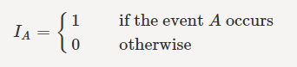
The indicator random variable for an event A has Bernoulli distribution with parameter p=P(A), so we can write
IA∼Bernoulli(P(A)).

Geometric Distribution
The random experiment behind the geometric distribution is as follows. Suppose that I have a coin with P(H)=p. I toss the coin until I observe the first heads. We define X as the total number of coin tosses in this experiment. Then X is said to have geometric distribution with parameter p. In other words, you can think of this experiment as repeating independent Bernoulli trials until observing the first success. This is exactly the same distribution that we saw in Example 3.4. The range of X here is RX={1,2,3,...}. In Example 3.4, we obtained
PX(k)=P(X=k)=(1−p)k−1p, for k=1,2,3,...
We usually define q=1−p, so we can write PX(k)=pqk−1, for k=1,2,3,... To say that a random variable has geometric distribution with parameter p, we write X∼Geometric(p). More formally, we have the following definition:

Definition
A random variable X is said to be a geometric random variable with parameter p, shown as X∼Geometric(p),if its PMF is given by
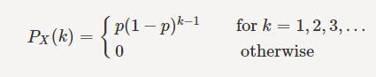
where 0<p<1.

Figure 3.3 shows the PMF of a Geometric(0.3) random variable.

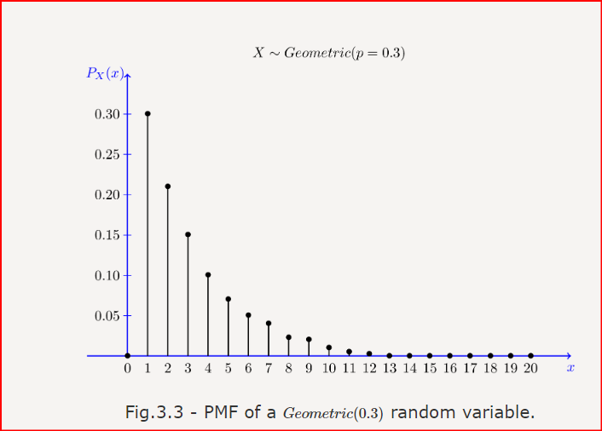

we should note that some books define geometric random variables slightly differently. They define the geometric random variable X as the total number of failures before observing the first success. By this definition the range of X is RX={0,1,2,...}and the PMF is given by

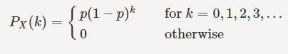

In this book, whenever we write X∼Geometric(p) we always mean X as the total number of trials as defined in Definition 3.5. Note that as long as you are consistent in your analysis, it does not matter which definition you use. That is why we emphasize that you should understand how to derive PMFs for these random variables rather than memorizing them.

Binomial Distribution
The random experiment behind the binomial distribution is as follows. Suppose that I have a coin with P(H)=p. I toss the coin n times and define X to be the total number of heads that I observe. Then X is binomial with parameter n and p, and we write X∼Binomial(n,p) The range of X in this case is RX={0,1,2,...,n}As we have seen in Section 2.1.3, the PMF of X in this case is given by binomial formula

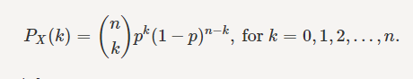
We have the following definition:

Definition
A random variable X is said to be a binomial random variable with parameters n and p, shown as X∼Binomial(n,p) if its PMF is given by

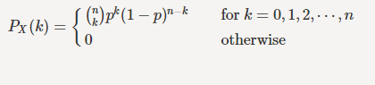

where 0<p<1

Figures 3.4 and 3.5 show the Binomial(n,p) PMF for n=10, p=0.3 and n=20, p=0.6 respectively.

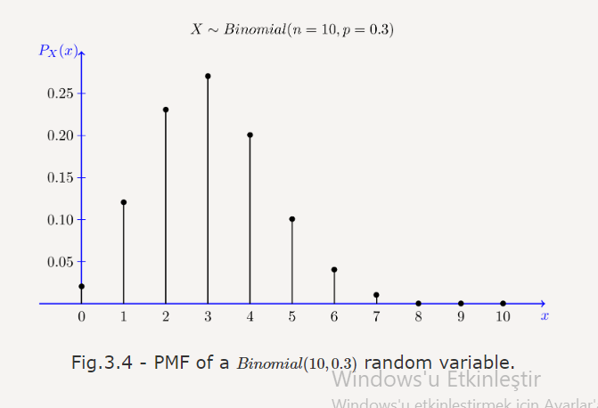

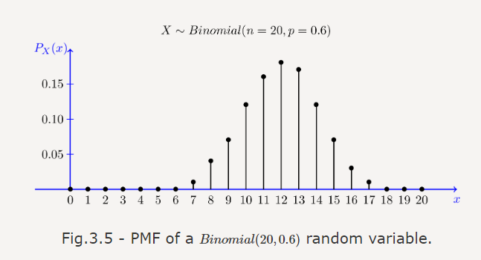

Binomial random variable as a sum of Bernoulli random variables
Here is a useful way of thinking about a binomial random variable. Note that a Binomial(n,p) random variable can be obtained by n independent coin tosses. If we think of each coin toss as a Bernoulli(p) random variable, the Binomial(n,p)random variable is a sum of n independent Bernoulli(p) random variables. This is stated more precisely in the following lemma.
Lemma
If X1,X2,...,Xn are independent Bernoulli(p) random variables, then the random variable X defined by X=X1+X2+...+Xn has a Binomial(n,p) distribution.
To generate a random variable X∼Binomial(n,p) we can toss a coin n times and count the number of heads. Counting the number of heads is exactly the same as finding X1+X2+...+Xn, where each Xi is equal to one if the corresponding coin toss results in heads and zero otherwise. This interpretation of binomial random variables is sometimes very helpful. Let's look at an example.

Example
Let X∼Binomial(n,p) and Y∼Binomial(m,p) be two independent random variables. Define a new random variable as Z=X+Y. Find the PMF of Z.

Since X∼Binomial(n,p), we can think of X as the number of heads in n independent coin tosses, i.e., we can write
X=X1+X2+...+Xn, ,
where the Xi's are independent Bernoulli(p) random variables. Similarly, since Y∼Binomial(m,p) we can think of Y as the number of heads in m independent coin tosses, i.e., we can write
Y=Y1+Y2+...+Ym,
where the Yj's are independent Bernoulli(p) random variables. Thus, the random variable Z=X+Y will be the total number of heads in n+m independent coin tosses:
Z=X+Y=X1+X2+...+Xn+Y1+Y2+...+Ym, ,
where the Xi's and Yj's are independent Bernoulli(p)) random variables. Thus, by Lemma 3.1, Z is a binomial random variable with parameters m+n and p, i.e., Binomial(m+n,p)). Therefore, the PMF of Z is

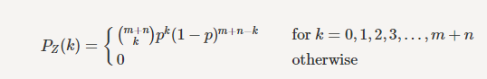

The above solution is elegant and simple, but we may also want to directly obtain the PMF of Z using probability rules. Here is another method to solve Example 3.7. First, we note that RZ={0,1,2,...,m+n}For k∈RZ, we can write
PZ(k)=P(Z=k)=P(X+Y=k).
We will find P(X+Y=k) by using conditioning and the law of total probability. In particular, we can write

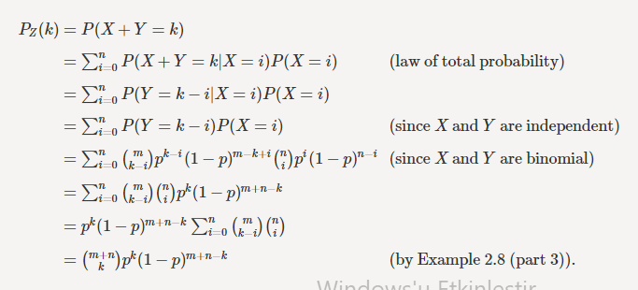

Thus, we have proved Z∼Binomial(m+n,p) by directly finding the PMF of Z.

Negative Binomial (Pascal) Distribution
The negative binomial or Pascal distribution is a generalization of the geometric distribution. It relates to the random experiment of repeated independent trials until observing m successes. Again, different authors define the Pascal distribution slightly differently, and as we mentioned before if you understand one of them you can easily derive the other ones. Here is how we define the Pascal distribution in this book. Suppose that I have a coin with P(H)=p. I toss the coin until I observe m heads, where m∈N. We define X as the total number of coin tosses in this experiment. Then X is said to have Pascal distribution with parameter m and p. We write X∼Pascal(m,p) Note that Pascal(1,p)=Geometric(p) Note that by our definition the range of X is given by RX={{m, m+1, m+2, m+3, ⋯}⋯}.
Let us derive the PMF of a Pascal(m,p) random variable X. Suppose that I toss the coin until I observe m heads, and X is defined as the total number of coin tosses in this experiment. To find the probability of the event A={X=k}we argue as follows. By definition, event A can be written as A=B∩C, where
- B is the event that we observe m−1 heads (successes) in the first k−1 trials, and
- C is the event that we observe a heads in the kth trial.
Note that B and C are independent events because they are related to different independent trials (coin tosses). Thus we can write
P(A)=P(B∩C)=P(B)P(C).
Now, we have P(C)=p. Note also that P(B) is the probability that I observe observe m−1 heads in the k−1 coin tosses. This probability is given by the binomial formula, in particular

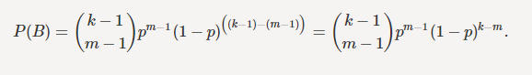

Thus, we obtain
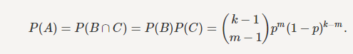

To summarize, we have the following definition for the Pascal random variable

Definition
A random variable X is said to be a Pascal random variable with parameters m and p, shown as X∼Pascal(m,p)), if its PMF is given by

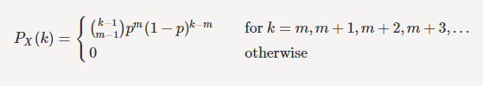
where 0<p<1.

Figure 3.6 shows the PMF of a Pascal(m,p) random variable with m=3 and p=0.5.
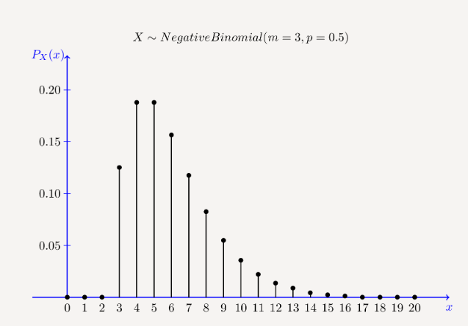

Fig.3.6 - PMF of a Pascal(3,0.5) (negative binomial) random variable.

Hypergeometric Distribution
Here is the random experiment behind the hypergeometric distribution. You have a bag that contains b blue marbles and r red marbles. You choose k≤b+r marbles at random (without replacement). Let X be the number of blue marbles in your sample. By this definition, we have X≤min(k,b). Also, the number of red marbles in your sample must be less than or equal to r, so we conclude X≥max(0,k−r). Therefore, the range of X is given by RX={max(0,k−r),max(0,k−r)+1,max(0,k−r)+2,...,min(k,b)}

to find PX(x), note that the total number of ways to choose k marbles from b+r marbles is (b+rk). The total number of ways to choose x blue marbles and k−x red marbles is (bx)(rk−x). Thus, we have

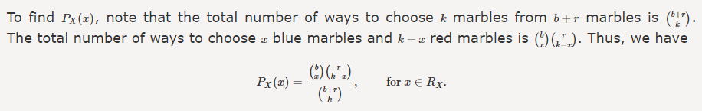

The following definition summarizes the discussion above.

Definition
A random variable X is said to be a Hypergeometric random variable with parameters b,r and k, shown as X∼Hypergeometric(b,r,k) if its range is RX={max(0,k−r),max(0,k−r)+1,max(0,k−r)+2,...,min(k,b)}, and its PMF is given by

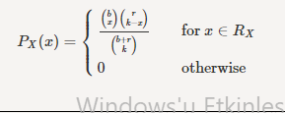

Again, there is no point to memorizing the PMF. All you need to know is how to solve problems that can be formulated as a hypergeometric random variable.

Poisson Distribution
The Poisson distribution is one of the most widely used probability distributions. It is usually used in scenarios where we are counting the occurrences of certain events in an interval of time or space. In practice, it is often an approximation of a real-life random variable. Here is an example of a scenario where a Poisson random variable might be used. Suppose that we are counting the number of customers who visit a certain store from 1pm to 2pm. Based on data from previous days, we know that on average λ=15 customers visit the store. Of course, there will be more customers some days and fewer on others. Here, we may model the random variable X showing the number customers as a Poisson random variable with parameter λ=15. Let us introduce the Poisson PMF first, and then we will talk about more examples and interpretations of this distribution.

Definition
A random variable X is said to be a Poisson random variable with parameter λ, shown as X∼Poisson(λ) if its range is RX={0,1,2,3,...}, and its PMF is given by

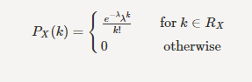

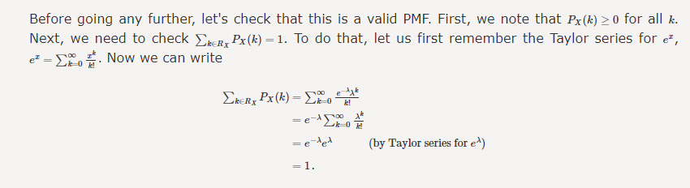

Figures 3.7, 3.8, and 3.9 show the Poisson(λ) PMF for λ=1, λ=5, and λ=10 respectively.

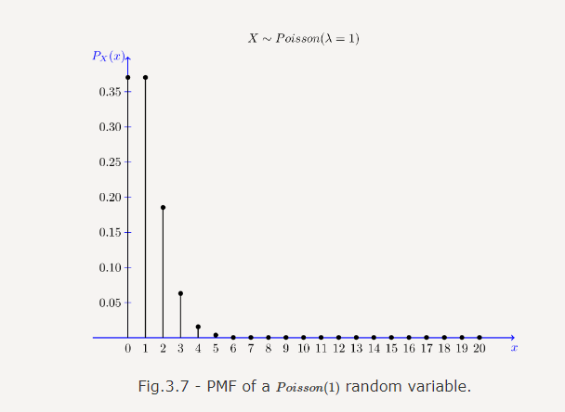

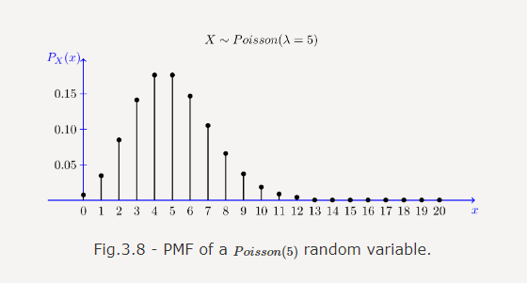

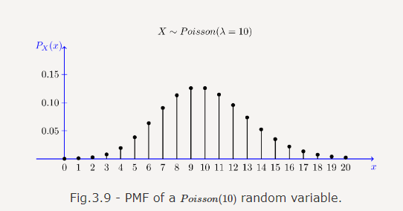

Now let's look at an example.
Example
The number of emails that I get in a weekday can be modeled by a Poisson distribution with an average of 0.2 emails per minute.
- What is the probability that I get no emails in an interval of length 5 minutes?
- What is the probability that I get more than 3 emails in an interval of length 10 minutes?

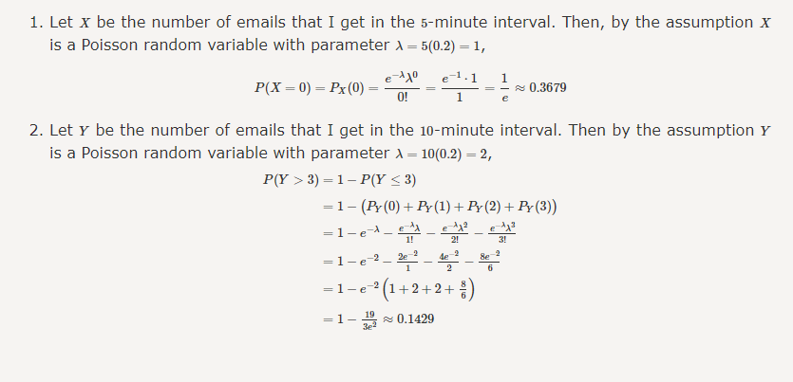

Poisson as an approximation for binomial
The Poisson distribution can be viewed as the limit of binomial distribution. Suppose X∼Binomial(n,p) where n is very large and p is very small. In particular, assume that λ=np is a positive constant. We show that the PMF of X can be approximated by the PMF of a Poisson(λ) random variable. The importance of this is that Poisson PMF is much easier to compute than the binomial. Let us state this as a theorem.

